Monday | Tuesday | Wednesday | Thursday | Friday
 |  | 1  Kindergarten Talent Show  (Students and Staff only) | 2 | 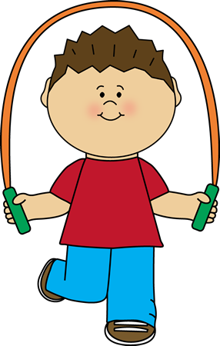  3  Jump Rope For Heart Activities
6  Ramadan Muabarak  Ramadan Starts  Dismissal at 2:30 pm | 7  Earthbound Mammals Workshop  Dismissal at  2:30 pm | 8  Dismissal at 2:30 pm | 9  Dismissal at 2:30 pm | 10  Dismissal at 2:30 pm
13  Sharing Stories | 14  Dismissal at 2:30 pm | 15  Dismissal at 2:30 pm | 16  Dismissal at 2:30 pm | 17  Dismissal at 2:30 pm
20  Dismissal at 2:30 pm | 21  Dismissal at 2:30 pm | 22  Dismissal at 2:30 pm | 23  Dismissal at 2:30 pm | 24  Dismissal at 2:30 pm
27  Have A Wonderful Summer Break!  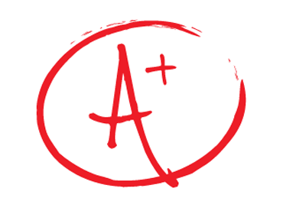  Report Cards Go Home  Dismissal at 2:30 pm | 28  Dismissal at 2:30 pm | 29  Last Day Of School  Dismissal at 2:30 pm
June 2016

